МІНІСТЕРСТВО ОСВІТИ І НАУКИ УКРАЇНИ

ХАРКІВСКИЙ НАЦІОНАЛЬНИЙ ЕКОНОМІЧНИЙ УНІВЕРСИТЕТ

ІМЕНИ СЕМЕНА КУЗНЕЦЯ

Лабораторна робота №7

Тема: «Building a simple network»

з дисципліни «Введення в мережі»

Виконав:

Студент групи 6.04.125.010.21.2

факультету Інформаційних технологій

спеціальності 125

П.І.П. Бойко В.В.

Перевірив:

Леуненко О.В.

Харків – 2022

Part 0

I have added 2 switches 2 PCs and I have connected it

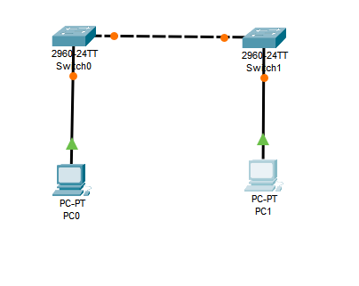

Also, I have renamed it to “S1” “S2” and “PC-A” “PC-B”

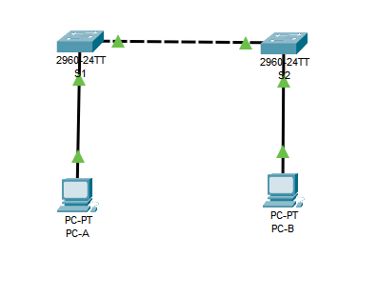

Next, I have change ip addresses for PCs

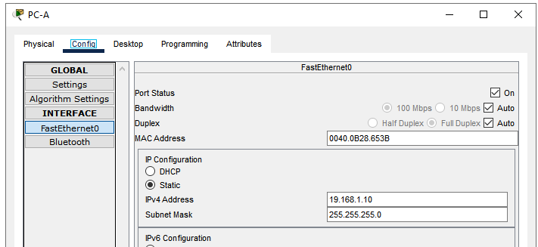

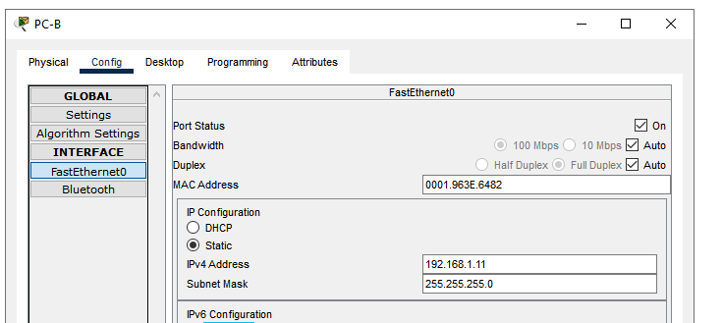

Part 1

Step 1

All devices were turned on

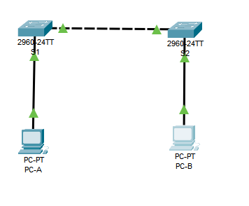

Step 2

Switches were connected with cable to 0/1 port

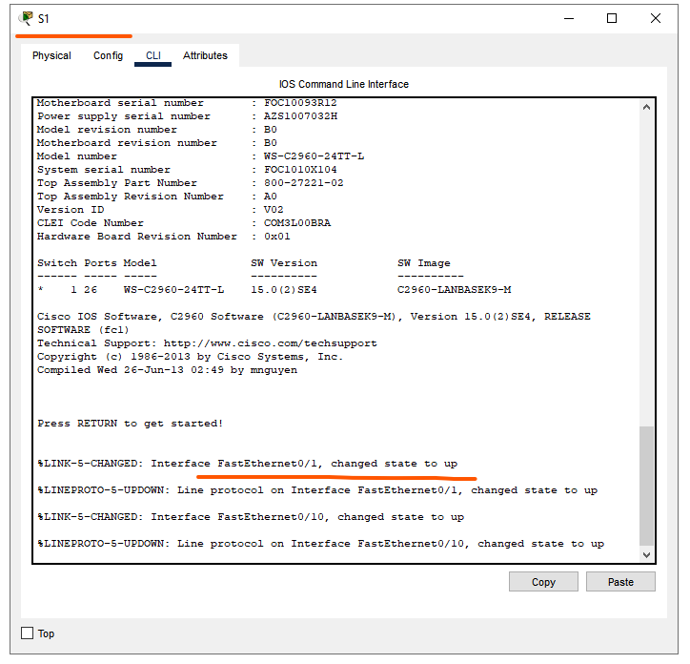

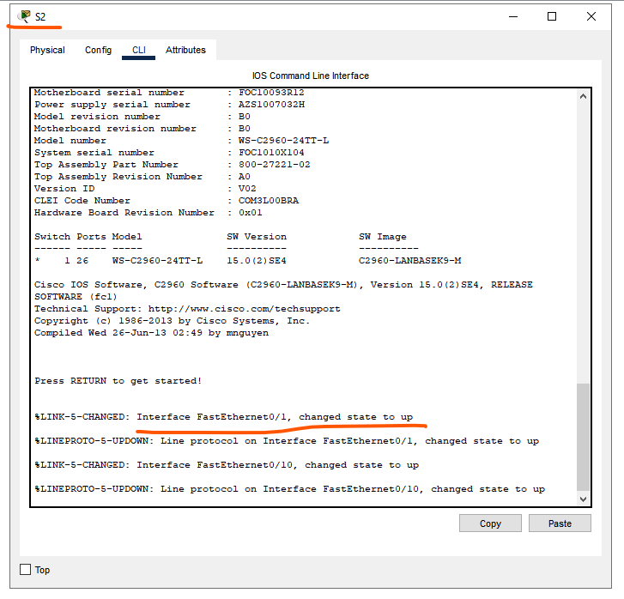

And connection is up

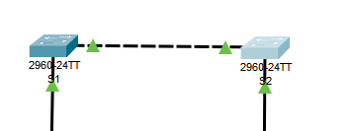

Step 3

I have changed ports of PCs connection

For “PC-A” and “S1”

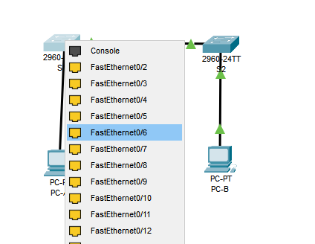

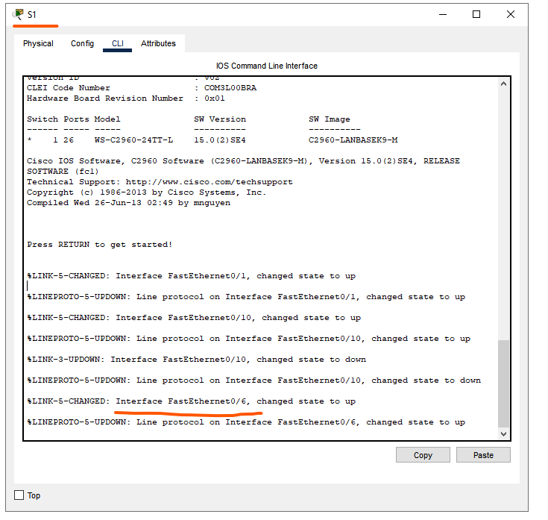

For “PC-B” and “S2”

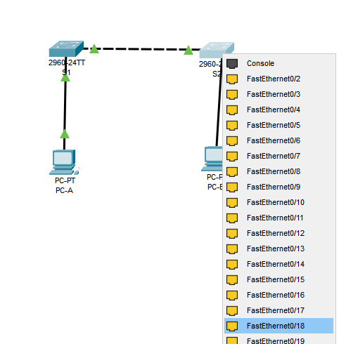

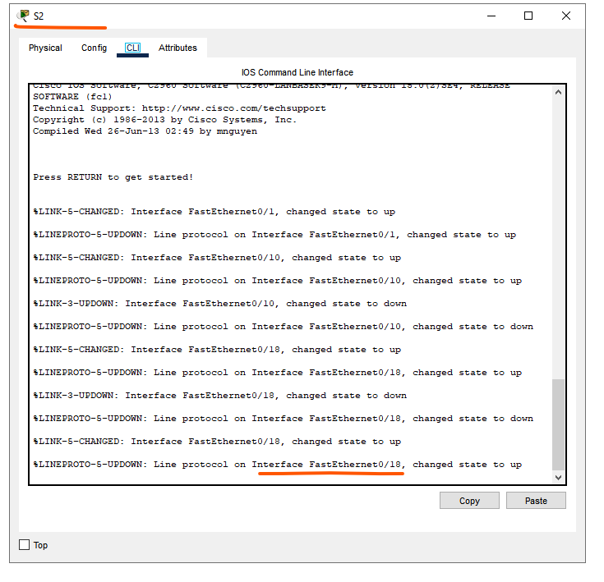

Step 4

There are green lights in the Packet tracer

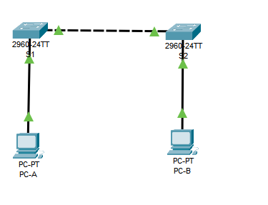

Part 2

Step 1 have already configured IP address

for “PC-A”

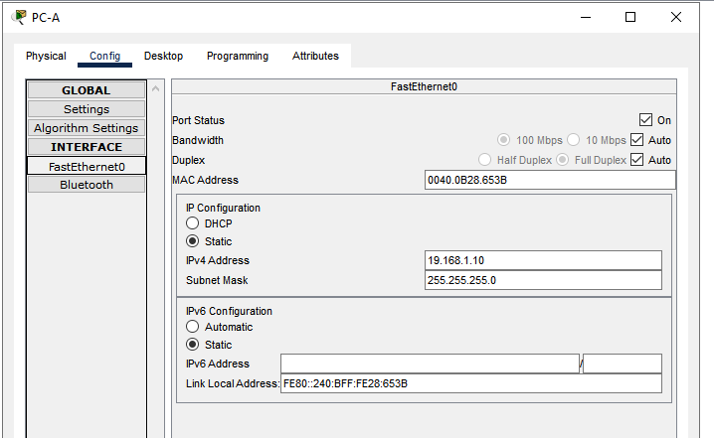

For “PC-B”

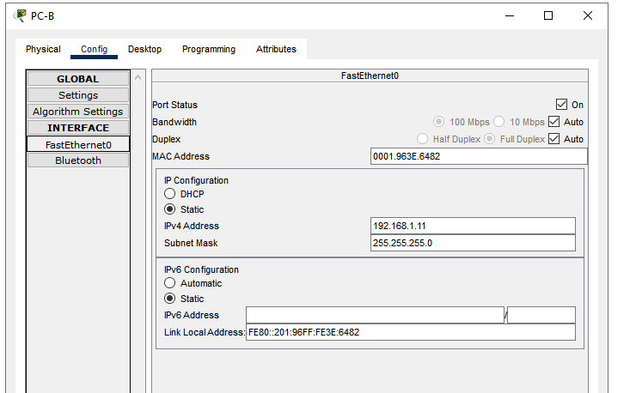

Step 2

On “PC-A” I have opened terminal and trying to ping “PC-B” by IP

I receive a problem, that PC-B is not available

I have fixed IP address

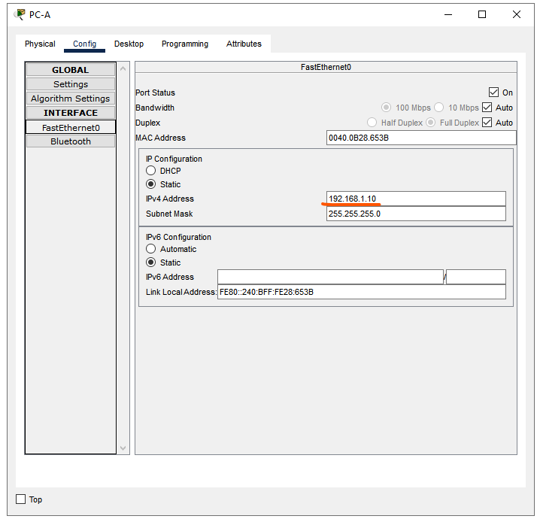

Trying to ping PC-B again

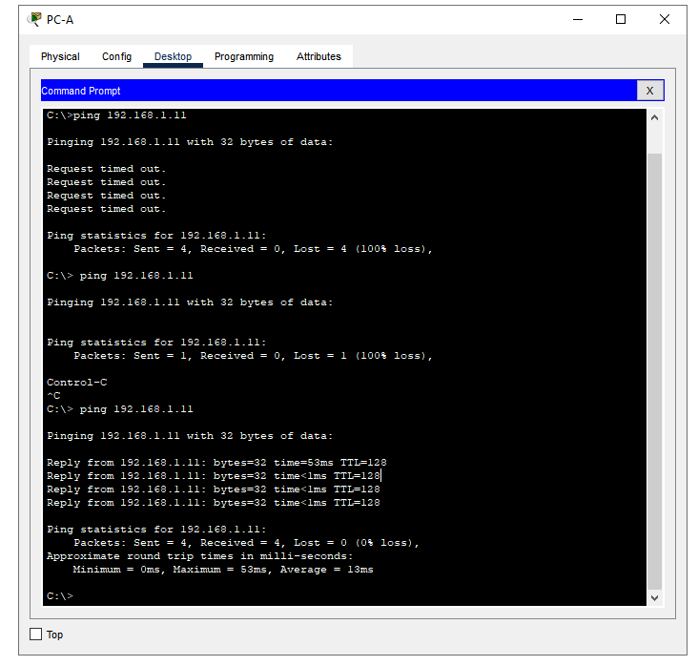

The same for PC-A

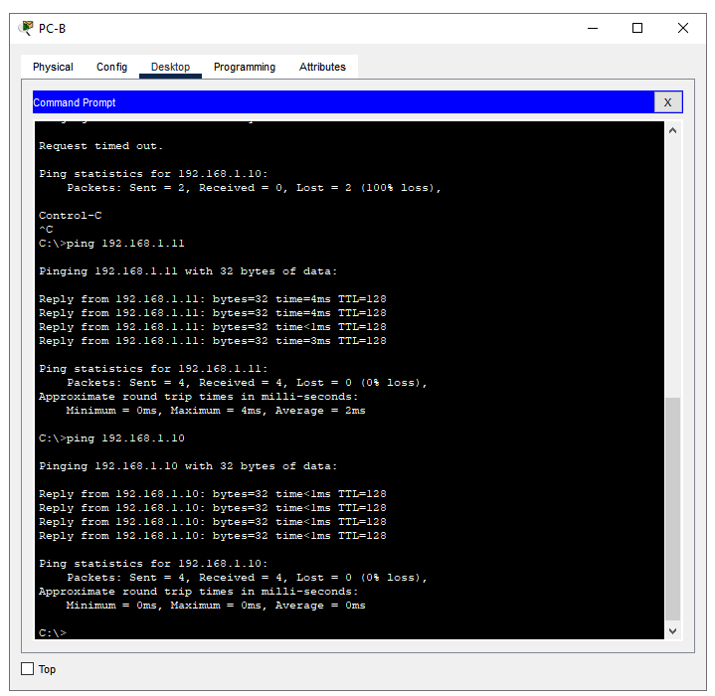

Part 3

Step 1

I have opened CLI on “S1”

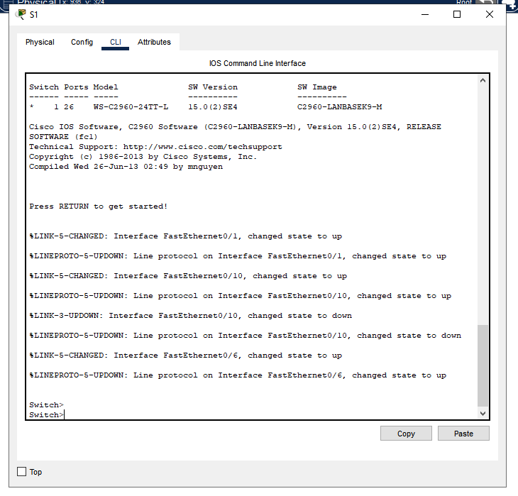

Step 2

I have typed “enable” command

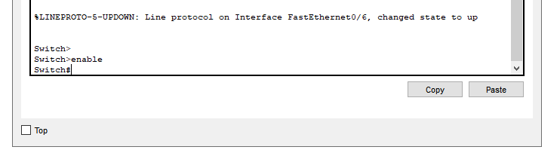

Step 3

I have typed “configure terminal” command

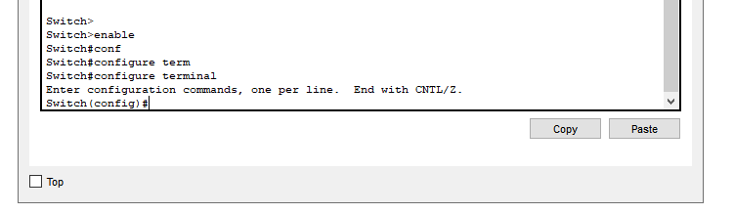

Step 4

I have typed “Hostname S1” for setting name to the switch

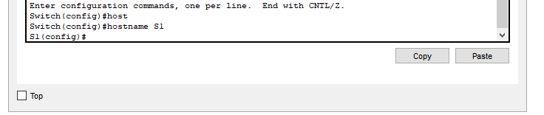

Step 5

With command “no ip domain-lookup” I have prevented unwanted DNS lookups

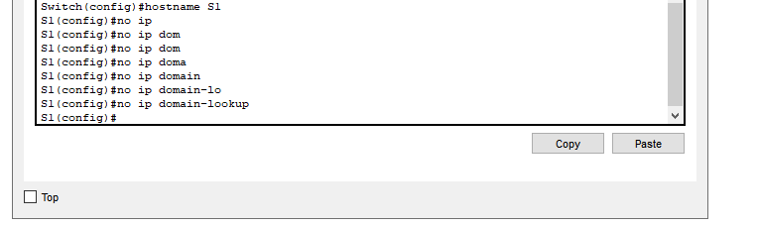

Step 6

With the following commands I have set local password

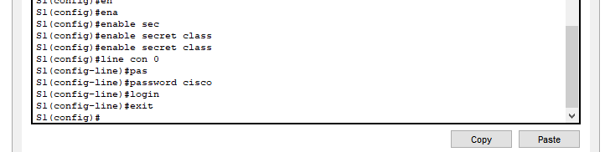

Step 7

I have set MOTD banner with the following command

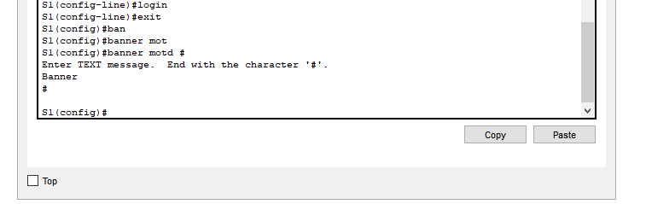

Step 8

I have saved config with the following command

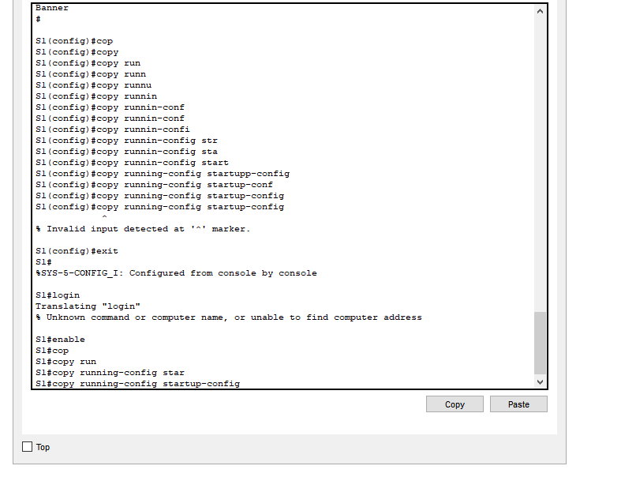

Step 9

For checking config I have typed “show running-config“

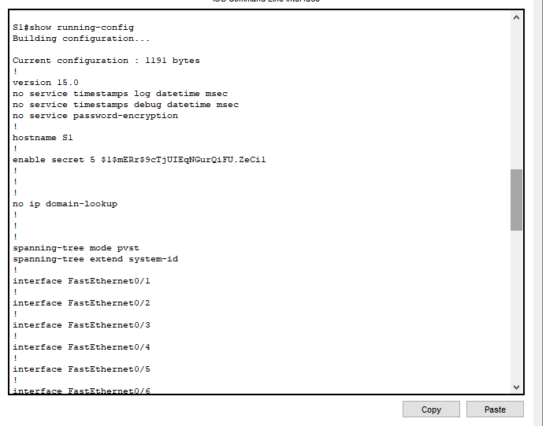

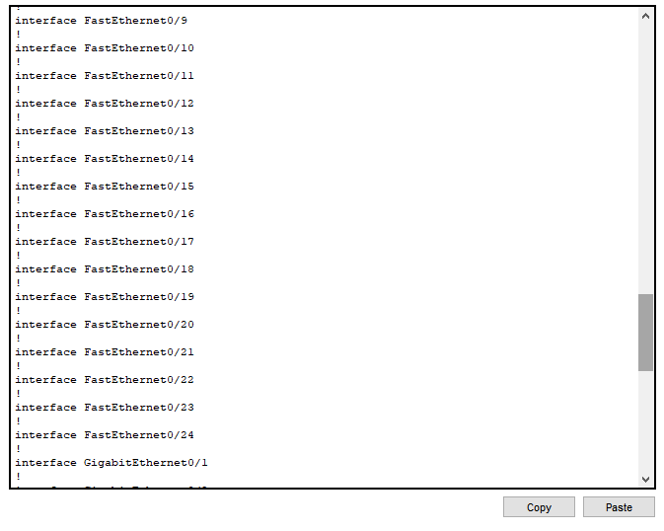

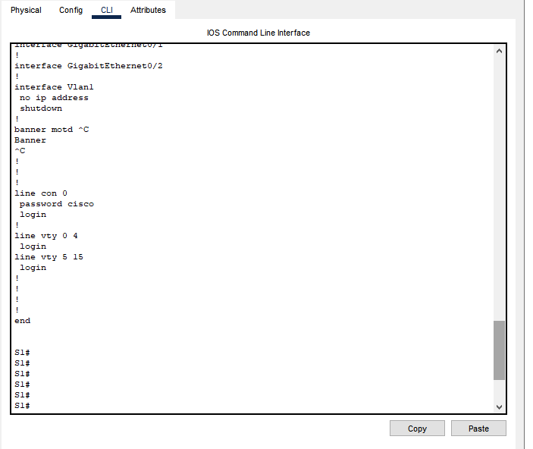

Step 10

For checking virsion I have typed “show version” command

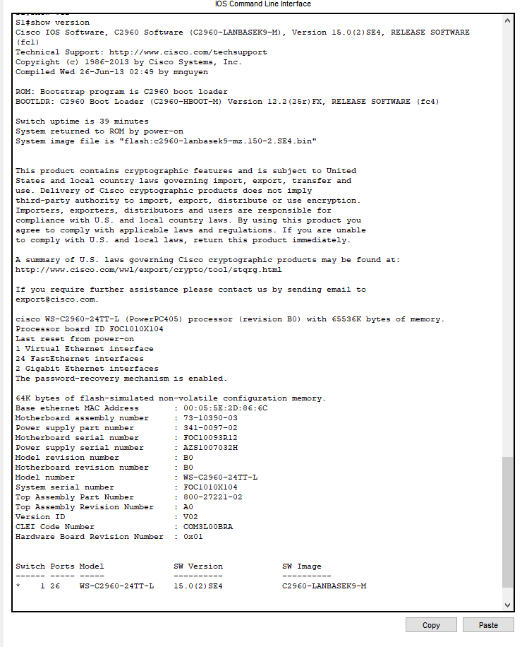

Step 11

For checking interfaces statuses, I have typed “show ip interface brief”

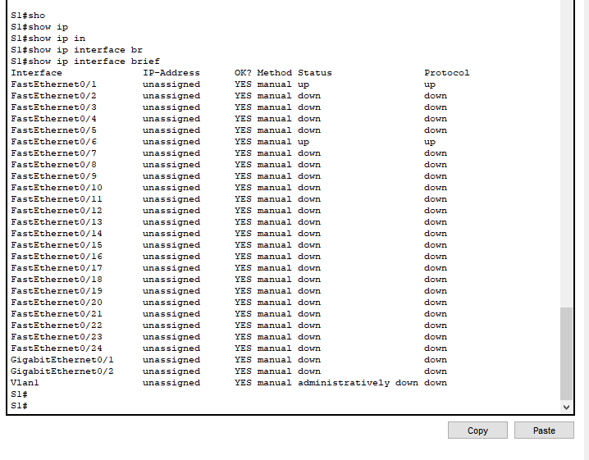

Step 12

I did the same for “S2”

